1.3 – Algebraic Expression

Exponential Function / Power: b^{x}
(Such as 2⁵, which represents 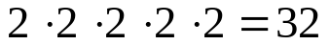)

Base: the number being multiplied; b

Exponent: the number of times the base is multiplied; x

Variable: a letter that is used to represent one or more numbers (x)

Coefficient: number multiplied to a variable
(Represented by a in a*x; 2 is the coefficient of 2x)

Evaluating Powers

Power ↔ Terms

Ex: 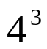=4*4*4=64

Quick Quiz:
Evaluate 5⁴
=625

Write 3*3*3*3*3*3*3*3 as a power

3^8

Order of Operations; PEMDAS (work left to right)
P = parenthesis (Please)
E = exponents (Excuse)
M = multiplication (My)
D = division (Dear)
A = addition (Aunt)
S = subtraction (Sally)

Ex: 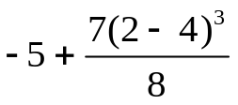=
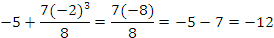

Quick Quiz: 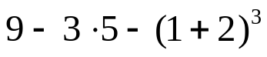

9-3*5-(3^3)=>
=9-3*5-27
=9-15-27= -33

Evaluating Expressions
Evaluating the expression = replacing the variables with numbers

Write Algebraic Expression → Replace Variables → Simplify

Ex: Evaluate 3(x +2) – 6x – 8 when x = 4

3(4+2)-6(4)-8=>
=3(6)-6(4)-8
=18-24-8
=-14

Quick Quiz: You have $40 and want to buy songs from itunes. Each song costs $1.75 to download. Write an expression for the how much money you would have left after buying and downloading your itunes, n. Evaluate the expression when n = 20 and n = 15.

40-1.75n

40-1.75(20) = 40-35 = $5 40-1.75(15)=40-26.25= $13.75

Simplifying Expressions
Combining like terms
- Like Terms: terms that have the same variable
(4x and 8x both have variable x)

Ex: Simplify 12(n² + n) – 3(n² – 2n)

12 n²+12n-3 n²+6n

= 9 n²+18n

Quick Quiz: Simplify 7x(x – 3) – 3(x + 4)+x^2

8x²-24x-12

HMWK:
Honors/Regular pg 22-23 #13-23 (odd), 33-37, 41-42, 52

